**Homework 2**

**Submit: Blackboard/Paper Due: Oct. 10th**

**Please write down Your Name & Student ID**

1. $5*{10}^{16}$ X-ray photons with energy of $50keV$ were incident into a $4cm$ thickness phantom, and finally reached the detector. The length of lead strip is 4cm and the separation of lead strip is 1cm. Assuming that Compton scattering will at most happen once during the travelling, and it can happen anywhere. Figure 1 shows several possibilities of X-ray propagation. Provided the linear attenuation of Phantom $5{cm}^{-1}$, calculate the energy range of X-ray which was detected by detector. (If you need any physical constant for the calculation, please refer to the course PPT)

Figure 1

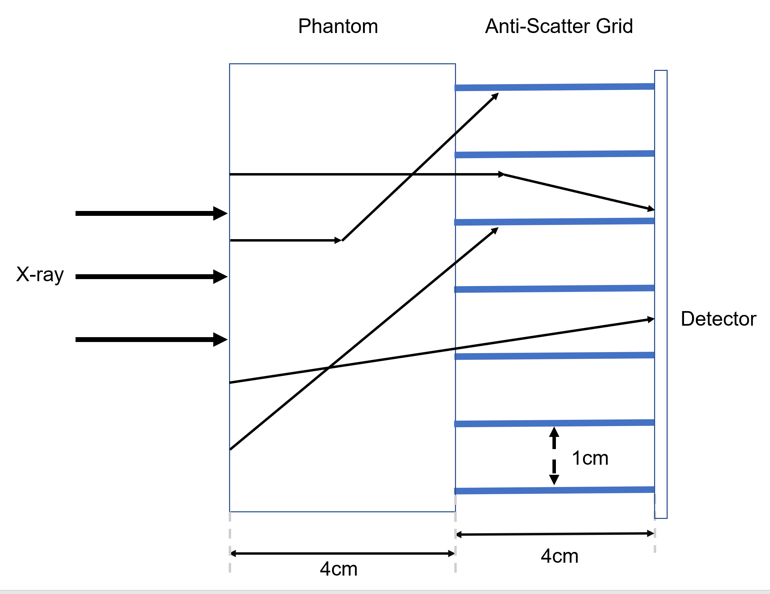

1. For the object shown in Figure 2(a), draw the projections that would be acquired at angles φ=0°, 45°, 90°, 135° and 180° (ignore beam hardening), and sketch the sinogram for values of φ from 0 to $180°$. Assume that a dark area corresponds to an area of high signal. The detail geometry relationship is shown as in Figure 2(b).

b

a

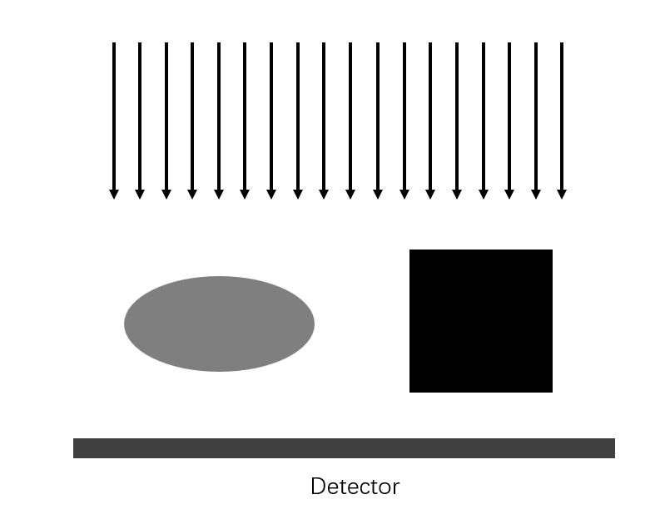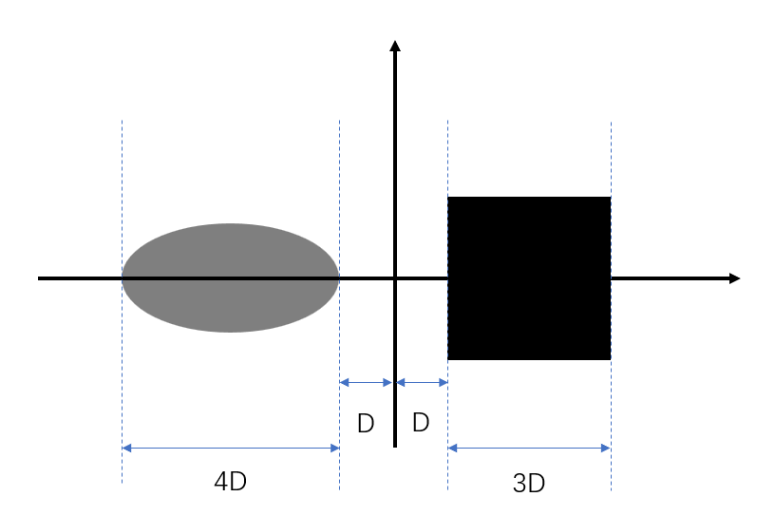

Figure 2

1. In mammographic examinations, the breast is compressed between two

plates. Answer the following with a brief explanation

(a) Is the geometric unsharpness increased or decreased by compression?

(b) Why is the image contrast improved by this procedure?

(c) Is the required X-ray dose for a given image SNR higher or lower with compression?

1. Given two different tissues *a* and *b,* two different detector sizes are used as indicated in the Figure 4. In the first case the detector is twice as large as in the second case.
2. Calculate the linear attenuation coefficients $μ_{a}$*, $μ_{b}$*  and $μ_{a+b}$ from the input intensity $I_{i}$ and the output intensities $I_{o}$, $I_{oa}$ and $I_{ob}$.
3. Show that $μ_{a+b}$ is always an underestimate of the mean linear attenuation $\frac{\left(μ_{a} +μ_{b}\right)}{2}$.
4. What is the influence of this underestimate on a reconstructed CT image? Explain.

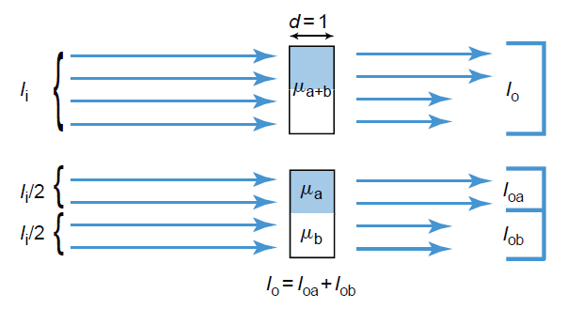

Figure 4